Physics Of A Jumperoo™
University of Alaska Fairbanks
Physics 211X Fall Semester 2013
Web Project
Aaron Holder

Physics of a Jumperoo™ |  | Home | Hooke’s Law | Newton’s Second Law | Conservation of Energy | Experiment:  Theory | Jumperoo™ Analysis | Bibliography

Hello if you have found this page, the depths of the internet have been opened for you. enjoy.

Why? You ask? Well the answer is varied, but mainly it’s a semester project for physics 211X at University of Alaska Fairbanks, and you are just inquisitive enough to do a Google search on how a Jumperoo™ really works. So let’s begin.
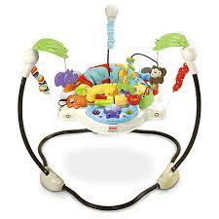
http://www.fisher-price.com/en_US/brands/babygear/products/55639
(n.d.)

A Jumperoo™ is fun for kids so it must work, there problem solved! No? We’ll bust into the physics of this toy in order to see what reality does to a spring and likewise what a spring does to reality.

We can familiarize ourselves with some of the laws of Physics and how they are applied in the use of a Jumperoo™.

 |  | Home | Hooke’s Law | Newton’s Second Law | Conservation of Energy | Experiment:  Theory | Jumperoo™ Analysis | Bibliography |  |  | UAF Physics 211X

Material for this page has been prepared as per request of Professor David Newman

Disclaimer: The Jumperoo is a trademarked product of the Fischer-Price® a subsidiary of Mattel®. All information in this report is collected for a third party source being nonaffiliated with either Mattel® or Fischer-Price®. And as such, the products actual mechanics is unknown to the author of this work. This is for educational purposes only.

